Honda Manufacturing of Indiana (HMIN)

Information Services

Regional Lot Control Test Plan
Version 1.1

Creation Date: 7/1/2011 7:45:00 AM

Last Saved: 9/9/2011 6:20:00 PM

TABLE OF CONTENTS

1. Revision History 5
1. Document Overview Document Overview 6
1.1. Referenced Documents 6
1.2. Acronym List 6
2. Environment 6
3. Test Execution 7
3.1. Test Case 1 – Normal Flow 7
3.1.1 Pre-Conditions 7
3.1.2 Purpose 7
3.1.3 Major Tables 7
3.1.4 Test Steps 7
3.1.5 Post-Conditions 11
3.2. Test Case 2 – VIN Not 17 Characters 12
3.2.1 Pre-Conditions 12
3.2.2 Purpose 12
3.2.3 Major Tables 12
3.2.4 Test Steps 12
3.2.5 Post-Conditions 13
3.3. Test Case 3 – VIN Does Not Exist 14
3.3.1 Pre-Conditions 14
3.3.2 Purpose 14
3.3.3 Major Tables 14
3.3.4 Test Steps 14
3.3.5 Post-Conditions 15
3.4. Test Case 4 – Serial Number Does Not Match Part Mask 16
3.4.1 Pre-Conditions 16
3.4.2 Purpose 16
3.4.3 Major Tables 16
3.4.4 Test Steps 16
3.4.5 Post-Conditions 18
3.5. Test Case 5 – Duplicate Serial Number 18
3.5.1 Pre-Conditions 18
3.5.2 Purpose 18
3.5.3 Major Tables 18
3.5.4 Test Steps 19
3.5.5 Post-Conditions 20
3.6. Test Case 6 – Invalid Instruction Code 20
3.6.1 Pre-Conditions 20
3.6.2 Purpose 20
3.6.3 Major Tables 20
3.6.4 Test Steps 21
3.6.5 Post-Conditions 21
3.7. Test Case 7 – Bad Torque Status From Torque Controller 21
3.7.1 Pre-Conditions 21
3.7.2 Purpose 22
3.7.3 Major Tables 22
3.7.4 Test Steps 22
3.7.5 Post-Conditions 23
3.8. Test Case 8 – Bad Torque Status From GALC 23
3.8.1 Pre-Conditions 23
3.8.2 Purpose 24
3.8.3 Major Tables 24
3.8.4 Test Steps 24
3.8.5 Post-Conditions 25
3.9. Test Case 9 – Maximum Number of Measurement Attempts for a Single Measurement Exceeded 25
3.9.1 Pre-Conditions 25
3.9.2 Purpose 25
3.9.3 Major Tables 26
3.9.4 Test Steps 26
3.9.5 Post-Conditions 28
3.10. Test Case 10 – Maximum Number of Measurement Attempts for a Single Part Exceeded 28
3.10.1 Pre-Conditions 28
3.10.2 Purpose 28
3.10.3 Major Tables 28
3.10.4 Test Steps 28
3.10.5 Post-Conditions 30
3.11. Test Case 11 – Turn off Device, Wait for Error Message and Turn Back on Device 30
3.11.1 Pre-Conditions 30
3.11.2 Purpose 31
3.11.3 Major Tables 31
3.11.4 Test Steps 31
3.11.5 Post-Conditions 32
3.12. Test Case 12 – Start Client with Device Disconnected 33
3.12.1 Pre-Conditions 33
3.12.2 Purpose 33
3.12.3 Major Tables 33
3.12.4 Test Steps 33
3.12.5 Post-Conditions 35
3.13. Test Case 13 – Skip part on last serial number 35
3.13.1 Pre-Conditions 35
3.13.2 Purpose 35
3.13.3 Major Tables 35
3.13.4 Test Steps 35
3.13.5 Post-Conditions 37
3.14. Test Case 14 – Reject the last serial number 37
3.14.1 Pre-Conditions 37
3.14.2 Purpose 37
3.14.3 Major Tables 37
3.14.4 Test Steps 37
3.14.5 Post-Conditions 39
3.15. Test Case 15 – Skip a measurement to another measurement with the same instruction code 39
3.15.1 Pre-Conditions 39
3.15.2 Purpose 40
3.15.3 Major Tables 40
3.15.4 Test Steps 40
3.15.5 Post-Conditions 42
3.16. Test Case 16 – Reject a measurement to another measurement with the same instruction code 42
3.16.1 Pre-Conditions 42
3.16.2 Purpose 42
3.16.3 Major Tables 43
3.16.4 Test Steps 43
3.16.5 Post-Conditions 45
3.17. Test Case 17 – Skip the last measurement 45
3.17.1 Pre-Conditions 45
3.17.2 Purpose 46
3.17.3 Major Tables 46
3.17.4 Test Steps 46
3.17.5 Post-Conditions 48
3.18. Test Case 18 – User is not a member of any active directory groups 48
3.18.1 Pre-Conditions 48
3.18.2 Purpose 48
3.18.3 Major Tables 48
3.18.4 Test Steps 49
3.18.5 Post-Conditions 50
3.19. Test Case 19 – Sequence Reset When VIN Not The Next Expected 50
3.19.1 Pre-Conditions 50
3.19.2 Purpose 50
3.19.3 Major Tables 51
3.19.4 Test Steps 51
3.19.5 Post-Conditions 54
3.20. Test Case 20 – Next VIN 54
3.20.1 Pre-Conditions 54
3.20.2 Purpose 54
3.20.3 Major Tables 54
3.20.4 Test Steps 55
3.20.5 Post-Conditions 56

Revision History
Revision | Section | Description | Editor | Date
1.0 | All | Original | Ryan Koors | 7/1/2011
1.1 | 3.4, 3.18, 3.19 | Added test cases for next expected sequence reset and user not a member of an active directory group. Modified part scan verification test case. | Ryan Koors | 7/22/11
Reviewers
Name | Position | Version | Comments
Approval Signatures
Name | Position | Version | Signature / Date

Document Overview Document Overview
This section describes the process that this test plan exercises.

Referenced Documents
The following documents are referenced as part of this _____document.

- None.

Acronym List
- GALC – Global Auto Line Control
- HMIN – Honda Manufacturing of Indiana
- HAM – Honda of America, Mfg.
- HMA – Honda Manufacturing of Alabama
- VIN – Vehicle Identification Number
- PL – Project Lead
- WE – Weld department
- ST – Stamping department
- AF – Auto Frame department
- VQ – Vehicle Quality department

Environment
This section describes the environment that the test was executed against.

Environment | WAS Version | App Server | DB Server | OPC Server | Device

Test Execution

Test Case 1 – Normal Flow

Pre-Conditions
- Process Point must be setup using configuration services
- PartName records must exist for all parts to be installed at the process point
  - PartName records can be created using the Part Category Maintenance screen
- Part records must exist for all parts to be installed at the process point
  - Part records can be created using the Part Maintenance screen
- LotControlRule records must exist for all parts to be installed at the process point for the MTOC of the VINs used in testing
  - LotControlRule records can be created using the Lot Control Rule Maintenance screen
- Execute the sql setup script for this process point. This resets the expected VIN for the process point and removes the product result, installed part, and measurement records for the VINs for this process point.

Purpose
The purpose of this station is to collect serial numbers and measurements for the parts installed at the station, and alert the user to any problems with the parts or frame.
What’s Accomplished?
The successful execution of this test case:
- Tests that the station functions without errors when all data is valid
- Tests that all serial numbers and measurements are recorded to the database successfully
- Tests that the station successfully enable and disables the gun
- Test that the station successfully changes the parameter set of the gun

Major Tables
- GAL185TBX Installed Part
- GAL143TBX Frame
- GAL215TBX Product Result
- GAL135TBX Expected Product
- HMIN_MEASUREMENT_ATTEMPTTBX Measurement Attempt

Test Steps
This section describes the steps to be taken in order to execute the test.

Step | Procedure | Expected Results | Actual Results | Pass/Fail
1 | Start the client station | The torque gun is disabled and the next expected VIN is displayed on the screen. | Torque gun disabled and expected VIN displayed | Pass
2 | Scan the Body Assembly Sheet or manually enter the next expected VIN | VIN is displayed on screen in the VIN field | Vin displayed | Pass
3 | System checks that the VIN is 17 characters | No errors occur | No errors | Pass
4 | System verifies the VIN is the next expected | The VIN field turns green | Vin field turned green | Pass
5 | The MTOC is displayed on the screen | No errors occur | No errors | Pass
6 | The screen displays text boxes for the serial numbers of all scan parts, and values of all measurements | No errors occur. The correct number of text boxes appear on the screen. | Correct boxes displayed | Pass
7 | Scan or manually enter a unique serial number for the current serial number text box | The S/N appears on the screen. | SN displayed | Pass
8 | System checks for a duplicate S/N on a different VIN. | No errors occur. | No errors | Pass
9 | System verifies the S/N matches the part mask. | No errors occur. | No errors | Pass
10 | System returns that the S/N is good | The current serial number text box turns green and the focus moves to the next serial number text box or measurement value text box | S/N box turned green, focus moved | Pass
11 | Repeat steps 7-11 for all serial number boxes | No errors occur | No errors | Pass
12 | On the first measurement of each part the system sends an enable and instruction code to the torque gun according to the lot control rule | The torque gun is enabled and the parameter set is correct | Gun enabled | Pass
13 | Perform a good torque for the current bolt | The torque controller shows a good torque. | As expected | Pass
14 | System checks the status and measurement values against the GALC limits | No errors occur | No errors | Pass
15 | System returns that the measurement is good | The current measurement field displays the measurement and turns green. Station is ready to receive next torque in under 700 ms | Measurement displayed in green box | Pass
16 | Repeat steps 13-17 for all measurement boxes | No errors occur | No errors | Pass
17 | System disables the torque gun | Torque gun is disabled | Gun disabled | Pass
18 | System creates a production results record and updates the last passing process point of the frame | Database contains a production result record for the VIN at this process point. The last passing process point column of the frame table is updated to this process point. | Database contains expected records | pass
19 | System updates the next expected VIN | The expect product record in the database for this process point is updated to the next VIN as determined by the in process product table | Expected product was updated | Pass
20 | System refreshes the screen | The screen is cleared. The Last Completed field displays the test VIN. The Next Expected field is updated to show the next VIN expected in sequence. | Screen refreshed | Pass

Step 1

Step 6 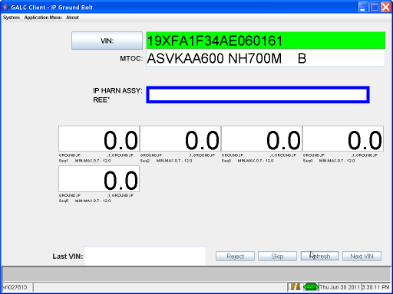

Step 10 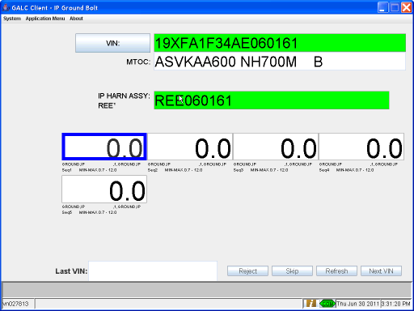

Step 15 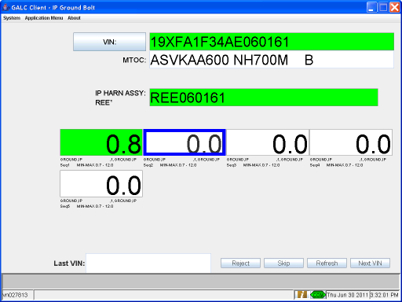

Step 20 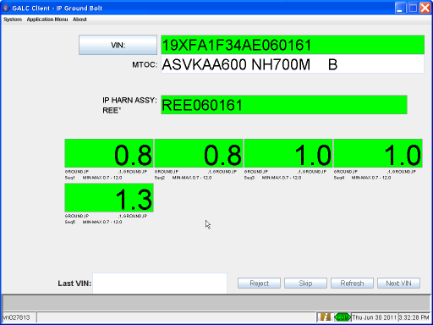

Step 21 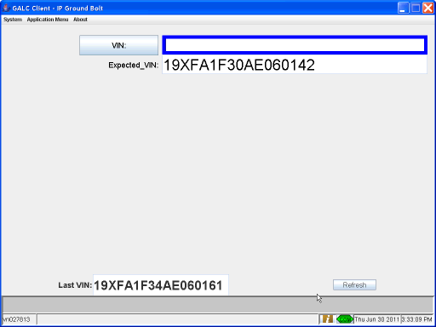

Post-Conditions
- Run the Cleanup.sql script for this station to remove the installed parts and product result records, update the last passing process point for the frame, and update the expected VIN for the process point

Test Case 2 – VIN Not 17 Characters

Pre-Conditions
- Process Point must be setup using configuration services
- PartName records must exist for all parts to be installed at the process point
  - PartName records can be created using the Part Category Maintenance screen
- Part records must exist for all parts to be installed at the process point
  - Part records can be created using the Part Maintenance screen
- LotControlRule records must exist for all parts to be installed at the process point for the MTOC of the VINs used in testing
  - LotControlRule records can be created using the Lot Control Rule Maintenance screen
- Execute the sql setup script for this process point. This resets the expected VIN for the process point and removes the product result, installed part, and measurement records for the VINs for this process point.

Purpose
The purpose of this station is to collect serial numbers and measurements for the parts installed at the station, and alert the user to any problems with the parts or frame.
What’s Accomplished?
The successful execution of this test case:
- Tests that the system successfully alerts the user and stops processing if a VIN is mistyped or misread by the scanner such that it does not appear to be 17 characters long.

Major Tables
- GAL185TBX Installed Part
- GAL143TBX Frame
- GAL215TBX Product Result
- GAL135TBX Expected Product
- HMIN_MEASUREMENT_ATTEMPTTBX Measurement Attempt

Test Steps
This section describes the steps to be taken in order to execute the test.

Step | Procedure | Expected Results | Actual Results | Pass/Fail
1 | Start the client station | The torque gun is disabled and the next expected VIN is displayed on the screen. | Gun disabled and expected vin displayed | Pass
2 | Scan the Body Assembly Sheet or manually enter a VIN that is less than 17 characters | VIN is displayed on screen in the VIN field | Vin displayed | Pass
3 | System checks that the VIN is 17 characters | Error “invalid length” is displayed on screen | Correct error displayed | Pass
4 | Scan the Body Assembly Sheet or manually enter the next expected VIN | VIN is displayed on screen in the VIN field | Vin displayed | Pass
5 | System checks that the VIN is 17 characters | No errors occur | No errors | Pass
6 | System verifies the VIN is the next expected | The VIN field turns green | VIN field turned green | Pass
7 | The MTOC is displayed on the screen | No errors occur and processing continues as normal | No errors | pass

Step 3 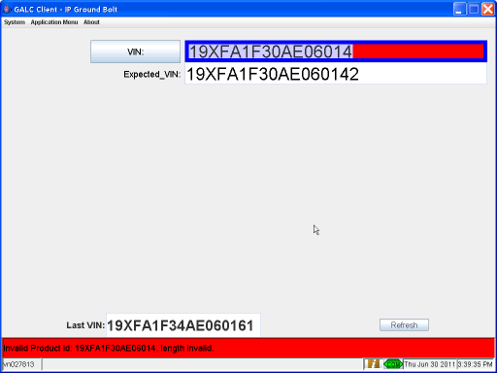

Step 4 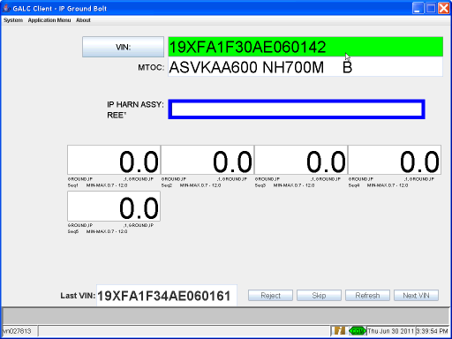

Post-Conditions
- Run the Cleanup.sql script for this station to remove the installed parts and product result records, update the last passing process point for the frame, and update the expected VIN for the process point

Test Case 3 – VIN Does Not Exist

Pre-Conditions
- Process Point must be setup using configuration services
- PartName records must exist for all parts to be installed at the process point
  - PartName records can be created using the Part Category Maintenance screen
- Part records must exist for all parts to be installed at the process point
  - Part records can be created using the Part Maintenance screen
- LotControlRule records must exist for all parts to be installed at the process point for the MTOC of the VINs used in testing
  - LotControlRule records can be created using the Lot Control Rule Maintenance screen
- Execute the sql setup script for this process point. This resets the expected VIN for the process point and removes the product result, installed part, and measurement records for the VINs for this process point.

Purpose
The purpose of this station is to collect serial numbers and measurements for the parts installed at the station, and alert the user to any problems with the parts or frame.
What’s Accomplished?
The successful execution of this test case:
- Test that the system successfully alerts the user and stops processing if the scanned VNI is not present in the Frame table.

Major Tables
- GAL185TBX Installed Part
- GAL143TBX Frame
- GAL215TBX Product Result
- GAL135TBX Expected Product
- HMIN_MEASUREMENT_ATTEMPTTBX Measurement Attempt

Test Steps
This section describes the steps to be taken in order to execute the test.

Step | Procedure | Expected Results | Actual Results | Pass/Fail
1 | Start the client station | The torque gun is disabled and the next expected VIN is displayed on the screen. | Gun disabled and expected vin displayed | Pass
2 | Scan the Body Assembly Sheet or manually enter a VIN that is not in the Frame table | VIN is displayed on screen in the VIN field | Vin displayed | Pass
3 | System checks that the VIN is 17 characters | Error “Unexpected product received” is displayed on screen | Correct error displayed | Pass
4 | Scan the Body Assembly Sheet or manually enter the next expected VIN | VIN is displayed on screen in the VIN field | Vin displayed | Pass
5 | System checks that the VIN is 17 characters | No errors occur | No errors | Pass
6 | System verifies the VIN is the next expected | The VIN field turns green | Vin field turned green | Pass
7 | The MTOC is displayed on the screen | No errors occur and processing continues as normal | No errors | Pass

Step 3 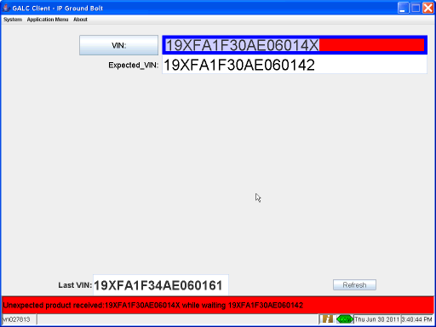

Post-Conditions
- Run the Cleanup.sql script for this station to remove the installed parts and product result records, update the last passing process point for the frame, and update the expected VIN for the process point

Test Case 4 – Serial Number Does Not Match Part Mask

Pre-Conditions
- Process Point must be setup using configuration services
- PartName records must exist for all parts to be installed at the process point
  - PartName records can be created using the Part Category Maintenance screen
- Part records must exist for all parts to be installed at the process point
  - Part records can be created using the Part Maintenance screen
- LotControlRule records must exist for all parts to be installed at the process point for the MTOC of the VINs used in testing
  - LotControlRule records can be created using the Lot Control Rule Maintenance screen
- Execute the sql setup script for this process point. This resets the expected VIN for the process point and removes the product result, installed part, and measurement records for the VINs for this process point.

Purpose
The purpose of this station is to collect serial numbers and measurements for the parts installed at the station, and alert the user to any problems with the parts or frame.
What’s Accomplished?
The successful execution of this test case:
- Tests that the system successfully alerts the user that the part serial number entered does not match the part mask for the current part.
- Tests that the system resumes processing successfully when a good serial number is scanned.

Major Tables
- GAL185TBX Installed Part
- GAL143TBX Frame
- GAL215TBX Product Result
- GAL135TBX Expected Product
- HMIN_MEASUREMENT_ATTEMPTTBX Measurement Attempt

Test Steps
This section describes the steps to be taken in order to execute the test.

Step | Procedure | Expected Results | Actual Results | Pass/Fail
1 | Execute steps 1 – 6 of the normal flow (Test Case 1) | Same as Test Case 1 | As expected | Pass
2 | Scan or manually enter a unique serial number for the current serial number text box that does not match the part mask | The S/N appears on the screen. | SN displayed | Pass
3 | System checks for a duplicate S/N on a different VIN. | No errors occur. | No errors | Pass
4 | System verifies the S/N matches the part mask. | NG sound is played once. Error: “part serial number verification failed” is displayed on the screen. The current serial number text box turns red. Processing is stopped until a matching S/N is entered, the Refresh button is clicked or the Next VIN button is clicked. | Correct sound played and error displayed | Pass
5 | Scan or manually enter a unique serial number for the current serial number text box | The S/N appears on the screen. | SN displayed | Pass
6 | System checks for a duplicate S/N on a different VIN. | No errors occur. | No errors | Pass
7 | System verifies the S/N matches the part mask. | No errors occur. | No errors | Pass
8 | System returns that the S/N is good | The current serial number text box turns green and the focus moves to the next serial number text box or measurement value text box. Processing continues as normal. | SN box turned green, processing continued | Pass

Step 4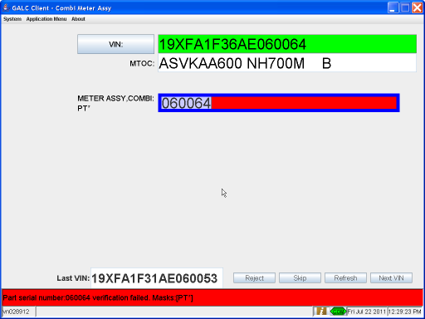

Step 9 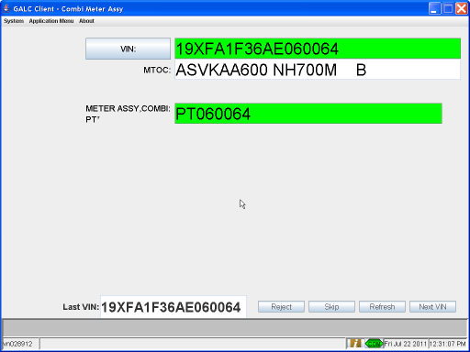

Post-Conditions
- Run the Cleanup.sql script for this station to remove the installed parts and product result records, update the last passing process point for the frame, and update the expected VIN for the process point

Test Case 5 – Duplicate Serial Number

Pre-Conditions
- Process Point must be setup using configuration services
- PartName records must exist for all parts to be installed at the process point
  - PartName records can be created using the Part Category Maintenance screen
- Part records must exist for all parts to be installed at the process point
  - Part records can be created using the Part Maintenance screen
- LotControlRule records must exist for all parts to be installed at the process point for the MTOC of the VINs used in testing
  - LotControlRule records can be created using the Lot Control Rule Maintenance screen
- Execute the sql setup script for this process point. This resets the expected VIN for the process point and removes the product result, installed part, and measurement records for the VINs for this process point.

Purpose
The purpose of this station is to collect serial numbers and measurements for the parts installed at the station, and alert the user to any problems with the parts or frame.
What’s Accomplished?
The successful execution of this test case:
- Tests that the system successfully alerts the user if a part serial number has already been associated with another VIN.\
- Tests that the system stops processing until the user acknowledges the alert.
- Tests that the system can continue processing after the user has scanned a correct serial number.

Major Tables
- GAL185TBX Installed Part
- GAL143TBX Frame
- GAL215TBX Product Result
- GAL135TBX Expected Product
- HMIN_MEASUREMENT_ATTEMPTTBX Measurement Attempt

Test Steps
This section describes the steps to be taken in order to execute the test.

Step | Procedure | Expected Results | Actual Results | Pass/Fail
1 | Execute steps 1 – 6 of the normal flow (Test Case 1) | Same as Test Case 1 | As expected | Pass
2 | Scan or manually enter a serial number for the current serial number text box that is already used on another VIN | The S/N appears on the screen. | SN displayed | Pass
3 | System checks for a duplicate S/N on a different VIN. | Errir “Part already installed on VIN” message displayed containing VIN with the duplicate serial number. | Correct error displayed | Pass
4 | Scan or manually enter a unique S/N that matches the part mask | The S/N appears on screen | SN displayed | Pass
5 | System checks for a duplicate S/N on a different VIN. | No errors occur. | No errors | Pass
6 | System verifies the S/N matches the part mask. | No errors occur. | No errors | Pass
7 | System returns that the S/N is good | The current serial number field turns green and processing continues as in normal flow | SN box turned green and processing continues | Pass

Step 3
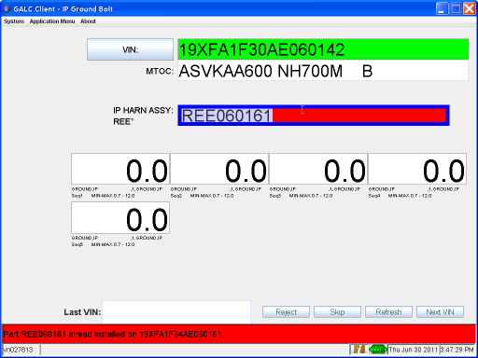

Post-Conditions
- Run the Cleanup.sql script for this station to remove the installed parts and product result records, update the last passing process point for the frame, and update the expected VIN for the process point

Test Case 6 – Invalid Instruction Code

Pre-Conditions
- Process Point must be setup using configuration services
- PartName records must exist for all parts to be installed at the process point
  - PartName records can be created using the Part Category Maintenance screen
- Part records must exist for all parts to be installed at the process point
  - Part records can be created using the Part Maintenance screen
- LotControlRule records must exist for all parts to be installed at the process point for the MTOC of the VINs used in testing
  - LotControlRule records can be created using the Lot Control Rule Maintenance screen
- Execute the sql setup script for this process point. This resets the expected VIN for the process point and removes the product result, installed part, and measurement records for the VINs for this process point.
- Use the Lot Control Rule Maintenance teamleader screen to change the instruction code for a part that requires a measurement to a value that in not valid in the torque controller

Purpose
The purpose of this station is to collect serial numbers and measurements for the parts installed at the station, and alert the user to any problems with the parts or frame.
What’s Accomplished?
The successful execution of this test case:
- Tests that the system successfully alerts the user that a problem exists if the is an error when enabling or disabling the gun or setting the parameter set.

Major Tables
- GAL185TBX Installed Part
- GAL143TBX Frame
- GAL215TBX Product Result
- GAL135TBX Expected Product
- HMIN_MEASUREMENT_ATTEMPTTBX Measurement Attempt

Test Steps
This section describes the steps to be taken in order to execute the test.

Step | Procedure | Expected Results | Actual Results | Pass/Fail
1 | Execute steps 1 – 12 of the normal flow (Test Case 1) | Same as Test Case 1 | As expected | Pass
2 | On the first measurement of each part the system sends an enable and instruction code to the torque gun according to the lot control rule | System returns an error that the instruction code is invalid and disables the torque gun. | Correct error displayed | Pass

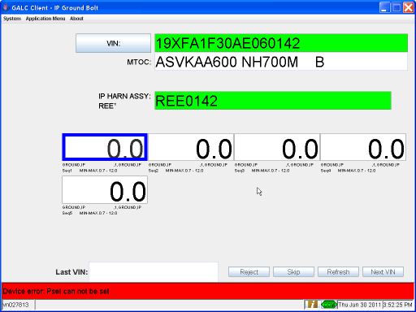

Post-Conditions
- Use the Lot Control Rule Maintenance teamleader screen to change the instruction code for the SRS Right Sensor to a value that is valid for the torque controller
- Run the Cleanup.sql script for this station to remove the installed parts and product result records, update the last passing process point for the frame, and update the expected VIN for the process point

Test Case 7 – Bad Torque Status From Torque Controller

Pre-Conditions
- Process Point must be setup using configuration services
- PartName records must exist for all parts to be installed at the process point
  - PartName records can be created using the Part Category Maintenance screen
- Part records must exist for all parts to be installed at the process point
  - Part records can be created using the Part Maintenance screen
- LotControlRule records must exist for all parts to be installed at the process point for the MTOC of the VINs used in testing
  - LotControlRule records can be created using the Lot Control Rule Maintenance screen
- Execute the sql setup script for this process point. This resets the expected VIN for the process point and removes the product result, installed part, and measurement records for the VINs for this process point.

Purpose
The purpose of this station is to collect serial numbers and measurements for the parts installed at the station, and alert the user to any problems with the parts or frame.
What’s Accomplished?
The successful execution of this test case:
- Tests that the system successfully alerts the user that a measurement was bad based on the torque controller’s status.
- Tests that the system records the bad measurement in the database correctly.
- Tests that the system does not move on to the next measurement when a bad measurement is recorded.
- Tests that the system moves to the next measurement correctly once the user has performed a successful retry of the measurement.

Major Tables
- GAL185TBX Installed Part
- GAL143TBX Frame
- GAL215TBX Product Result
- GAL135TBX Expected Product
- HMIN_MEASUREMENT_ATTEMPTTBX Measurement Attempt

Test Steps
This section describes the steps to be taken in order to execute the test.

Step | Procedure | Expected Results | Actual Results | Pass/Fail
1 | Execute steps 1 – 13 of the normal flow (Test Case 1) | Same as Test Case 1 | As expected | Pass
2 | Perform a torque for the current bolt that is outside the limits set on the torque controller but inside the limits set in GALC | The torque controller shows a bad torque | Gun shows bad torque | Pass
3 | System checks the status and measurement values against the GALC limits | No errors occur | No errors | Pass
4 | System returns that the measurement is bad | The current measurement field displays the measurement and turns red | Measurement displayed in red | Pass
5 | Perform a good torque for the current bolt | No errors occur. | No errors | pass
6 | System checks the status and measurement values against the GALC limits | No errors occur | No errors | Pass
7 | System returns that the measurement is good | The current measurement field is updated with the measurement and turns green. Processing continues as in normal flow. | Measurement displayed in green, processing continued | Pass

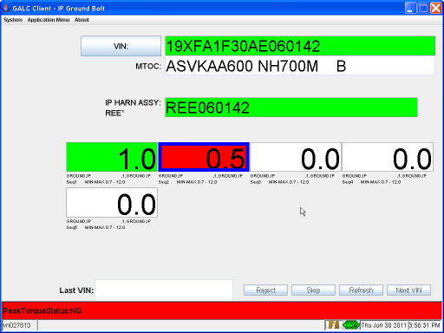

Post-Conditions
- Run the Cleanup.sql script for this station to remove the installed parts and product result records, update the last passing process point for the frame, and update the expected VIN for the process point

Test Case 8 – Bad Torque Status From GALC

Pre-Conditions
- Process Point must be setup using configuration services
- PartName records must exist for all parts to be installed at the process point
  - PartName records can be created using the Part Category Maintenance screen
- Part records must exist for all parts to be installed at the process point
  - Part records can be created using the Part Maintenance screen
- LotControlRule records must exist for all parts to be installed at the process point for the MTOC of the VINs used in testing
  - LotControlRule records can be created using the Lot Control Rule Maintenance screen
- Execute the sql setup script for this process point. This resets the expected VIN for the process point and removes the product result, installed part, and measurement records for the VINs for this process point.

Purpose
The purpose of this station is to collect serial numbers and measurements for the parts installed at the station, and alert the user to any problems with the parts or frame.
What’s Accomplished?
The successful execution of this test case:
- Tests that the system successfully alerts the user that a measurement was bad based on the limits set in GALC even if the torque controller gives the measurement a good status.
- Tests that the system records the bad measurement in the database correctly.
- Tests that the system does not move on to the next measurement when a bad measurement is recorded.
- Tests that the system moves to the next measurement correctly once the user has performed a successful retry of the measurement.

Major Tables
- GAL185TBX Installed Part
- GAL143TBX Frame
- GAL215TBX Product Result
- GAL135TBX Expected Product
- HMIN_MEASUREMENT_ATTEMPTTBX Measurement Attempt

Test Steps
This section describes the steps to be taken in order to execute the test.

Step | Procedure | Expected Results | Actual Results | Pass/Fail
1 | Execute steps 1 – 13 of the normal flow (Test Case 1) | Same as Test Case 1 | As expected | Pass
2 | Perform a torque for the current bolt that is inside the limits set on the torque controller but outside the limits set in GALC | The torque controller shows a good torque. | As expected | Pass
3 | System checks the status and measurement values against the GALC limits | No errors occur | No errors | Pass
4 | System returns that the measurement is bad | The current measurement field displays the measurement and turns red | Measurement displayed in red | Pass
5 | Perform a good torque for the current bolt | No errors occur. | No errors | pass
6 | System checks the status and measurement values against the GALC limits | No errors occur | No errors | Pass
7 | System returns that the measurement is good | The current measurement field is updated with the measurement and turns green. Processing continues as in normal flow. | Measurement displayed in green, processing continued | Pass

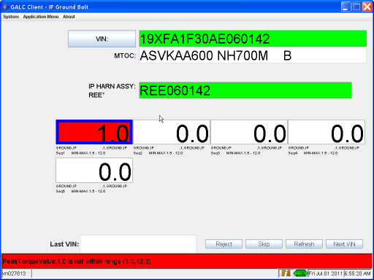

Post-Conditions
- Run the Cleanup.sql script for this station to remove the installed parts and product result records, update the last passing process point for the frame, and update the expected VIN for the process point

Test Case 9 – Maximum Number of Measurement Attempts for a Single Measurement Exceeded

Pre-Conditions
- Process Point must be setup using configuration services
- PartName records must exist for all parts to be installed at the process point
  - PartName records can be created using the Part Category Maintenance screen
- Part records must exist for all parts to be installed at the process point
  - Part records can be created using the Part Maintenance screen
- LotControlRule records must exist for all parts to be installed at the process point for the MTOC of the VINs used in testing
  - LotControlRule records can be created using the Lot Control Rule Maintenance screen
- Execute the sql setup script for this process point. This resets the expected VIN for the process point and removes the product result, installed part, and measurement records for the VINs for this process point.

Purpose
The purpose of this station is to collect serial numbers and measurements for the parts installed at the station, and alert the user to any problems with the parts or frame.
What’s Accomplished?
The successful execution of this test case:
- Tests that the system stops processing when the maximum number of retries allowed for a measurement has been reached.
- Tests that the system alerts the user that the maximum number of retries allowed for a measurement has been reached.
- Tests that the system disables the gun when the maximum number of retries allowed for a measurement has been reached.

Major Tables
- GAL185TBX Installed Part
- GAL143TBX Frame
- GAL215TBX Product Result
- GAL135TBX Expected Product
- HMIN_MEASUREMENT_ATTEMPTTBX Measurement Attempt

Test Steps
This section describes the steps to be taken in order to execute the test.

Step | Procedure | Expected Results | Actual Results | Pass/Fail
1 | Execute steps 1 – 13 of the normal flow (Test Case 1) | Same as Test Case 1 | As expected | Pass
2 | Perform a torque for the current bolt that is outside the limits set on the torque controller or outside the limits set in GALC | The torque controller shows a good or bad status | As expected | Pass
3 | System checks the status and measurement values against the GALC limits | No errors occur | No errors | Pass
4 | System returns that the measurement is bad | The current measurement field displays the measurement and turns red | Measurement displayed in red | Pass
5 | Repeat steps 2-4 until the maximum number of attempts specified for the individual measurement in the part maintenance screen is reached | When the maximum number of attempts has been reached and the last attempt was bad error appears and displays the message, “The Maximum Attempts of NG Torques has been exceeded.” | Error displayed | Pass
6 | System records the measurement attempt in the database | Database contains the measurement attempt records with a bad status | Records created | Pass
7 | Click OK on the pop-up window | No errors occur. | No errors | Pass
8 | System creates a production results record and updates the last passing process point of the frame | Database contains a production result record for the VIN at this process point. The last passing process point column of the frame table is updated to this process point. | Records created | Pass
9 | System updates the next expected VIN | The expect product record in the database for this process point is updated to the next VIN as determined by the in process product table | Expected vin updated | Pass
10 | System refreshes the screen | The screen is cleared. The Last Completed field displays the test VIN. The Next Expected field is updated to show the next VIN expected in sequence. | Screen refreshed | pass

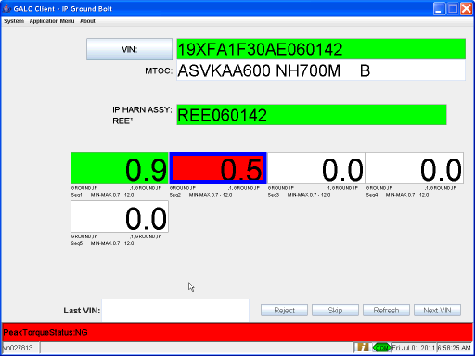

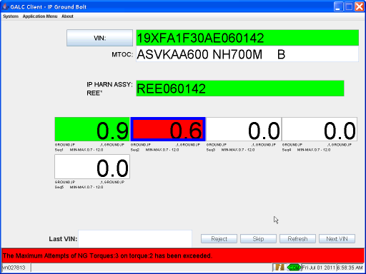

Post-Conditions
- Run the Cleanup.sql script for this station to remove the installed parts and product result records, update the last passing process point for the frame, and update the expected VIN for the process point

Test Case 10 – Maximum Number of Measurement Attempts for a Single Part Exceeded

Pre-Conditions
- Process Point must be setup using configuration services
- PartName records must exist for all parts to be installed at the process point
  - PartName records can be created using the Part Category Maintenance screen
- Part records must exist for all parts to be installed at the process point
  - Part records can be created using the Part Maintenance screen
- LotControlRule records must exist for all parts to be installed at the process point for the MTOC of the VINs used in testing
  - LotControlRule records can be created using the Lot Control Rule Maintenance screen
- Execute the sql setup script for this process point. This resets the expected VIN for the process point and removes the product result, installed part, and measurement records for the VINs for this process point.

Purpose
The purpose of this station is to collect serial numbers and measurements for the parts installed at the station, and alert the user to any problems with the parts or frame.
What’s Accomplished?
The successful execution of this test case:
- Tests that the system stops processing when the maximum number of retries allowed for a measurement has been reached.
- Tests that the system alerts the user that the maximum number of retries allowed for a measurement has been reached.
- Tests that the system disables the gun when the maximum number of retries allowed for a measurement has been reached.

Major Tables
- GAL185TBX Installed Part
- GAL143TBX Frame
- GAL215TBX Product Result
- GAL135TBX Expected Product
- HMIN_MEASUREMENT_ATTEMPTTBX Measurement Attempt

Test Steps
This section describes the steps to be taken in order to execute the test.

Step | Procedure | Expected Results | Actual Results | Pass/Fail
1 | Execute steps 1 – 13 of the normal flow (Test Case 1) | Same as Test Case 1 | As expected | Pass
2 | Perform a torque for the current bolt that is outside the limits set on the torque controller or outside the limits set in GALC | The torque controller shows a good or bad status | As expected | Pass
3 | System checks the status and measurement values against the GALC limits | No errors occur | No errors | Pass
4 | System returns that the measurement is bad | The current measurement field displays the measurement and turns red | Measurement displayed in red | Pass
5 | Perform a torque for the current bolt that is within the limits set on the torque controller or outside the limits set in GALC | The torque controller shows a good or bad status | As expected | Pass
6 | System checks the status and measurement values against the GALC limits | No errors occur | No errors | Pass
7 | System returns that the measurement is good | The current measurement field displays the measurement and turns green. | Measurement displayed in red | Pass
8 | Perform a torque for the current bolt that is outside the limits set on the torque controller or outside the limits set in GALC | The torque controller shows a good or bad status | As expected | Pass
9 | System checks the status and measurement values against the GALC limits | No errors occur | No errors | Pass
10 | System returns that the measurement is bad | The current measurement field displays the measurement and turns red | Measurement displayed in red | Pass
11 | Repeat steps 2-4 until the maximum number of attempts specified for the individual measurement in the part maintenance screen is reached | When the maximum number of attempts has been reached and the last attempt was bad pop-up window appears and displays the message, “The Part Maximum Attempt of NG Torques has been exceeded.” | Error displayed | Pass
12 | System records the measurement attempt in the database | Database contains the measurement attempt records with a bad status | Records created | Pass
13 | Click OK on the pop-up window | No errors occur. | No errors | Pass
14 | System creates a production results record and updates the last passing process point of the frame | Database contains a production result record for the VIN at this process point. The last passing process point column of the frame table is updated to this process point. | Records created | Pass
15 | System updates the next expected VIN | The expect product record in the database for this process point is updated to the next VIN as determined by the in process product table | Expected vin updated | Pass
16 | System refreshes the screen | The screen is cleared. The Last Completed field displays the test VIN. The Next Expected field is updated to show the next VIN expected in sequence. | Screen refreshed | pass

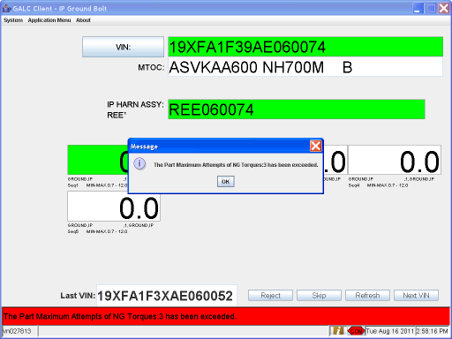

Post-Conditions
- Run the Cleanup.sql script for this station to remove the installed parts and product result records, update the last passing process point for the frame, and update the expected VIN for the process point

Test Case 11 – Turn off Device, Wait for Error Message and Turn Back on Device

Pre-Conditions
- Process Point must be setup using configuration services
- PartName records must exist for all parts to be installed at the process point
  - PartName records can be created using the Part Category Maintenance screen
- Part records must exist for all parts to be installed at the process point
  - Part records can be created using the Part Maintenance screen
- LotControlRule records must exist for all parts to be installed at the process point for the MTOC of the VINs used in testing
  - LotControlRule records can be created using the Lot Control Rule Maintenance screen
- Execute the sql setup script for this process point. This resets the expected VIN for the process point and removes the product result, installed part, and measurement records for the VINs for this process point.

Purpose
The purpose of this station is to collect serial numbers and measurements for the parts installed at the station, and alert the user to any problems with the parts or frame.
What’s Accomplished?
The successful execution of this test case:
1.Tests that the gun and terminal reconnect properly even when the gun did not realize it was disconnected.

Major Tables
- GAL185TBX Installed Part
- GAL143TBX Frame
- GAL215TBX Product Result
- GAL135TBX Expected Product
- HMIN_MEASUREMENT_ATTEMPTTBX Measurement Attempt

Test Steps
This section describes the steps to be taken in order to execute the test.

Step | Procedure | Expected Results | Actual Results | Pass/Fail
1 | Execute steps 1 – 11 of the normal flow (Test Case 1) | Same as Test Case 1 | As expected | Pass
2 | On the first measurement of each part the system sends an enable and instruction code to the torque gun according to the lot control rule | The torque gun is enabled and the parameter set is correct | Gun enabled with correct pset | Pass
3 | Perform a good torque for the current bolt | The torque controller shows a good torque. | Controller showed good torque | Pass
4 | System checks the status and measurement values against the GALC limits | No errors occur | As expected | Pass
5 | System returns that the measurement is good | The current measurement field displays the measurement and turns green | Measurement turned green | pass
6 | Turn off torque gun | Gun powered off | As expected | Pass
7 | Client disconnects from gun | Error message is displayed “Device disconnected” | Correct error displayed | Pass
8 | Turn torque gun back on as soon as error message is received | Once gun is restarted the error message should disappear | Error disappeared | Pass
9 | Perform a good torque for the current bolt | The torque controller shows a good torque. Processing continues as in normal flow | Measurement shown good. Results same as normal flow | Pass

Step 7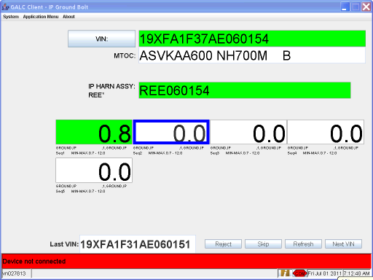

Step 8 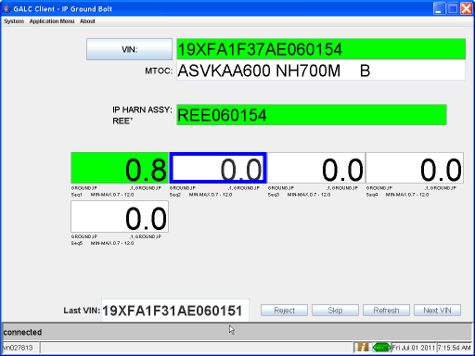

Post-Conditions
- Run the Cleanup.sql script for this station to remove the installed parts and product result records, update the last passing process point for the frame, and update the expected VIN for the process point

Test Case 12 – Start Client with Device Disconnected

Pre-Conditions
- Process Point must be setup using configuration services
- PartName records must exist for all parts to be installed at the process point
  - PartName records can be created using the Part Category Maintenance screen
- Part records must exist for all parts to be installed at the process point
  - Part records can be created using the Part Maintenance screen
- LotControlRule records must exist for all parts to be installed at the process point for the MTOC of the VINs used in testing
  - LotControlRule records can be created using the Lot Control Rule Maintenance screen
- Execute the sql setup script for this process point. This resets the expected VIN for the process point and removes the product result, installed part, and measurement records for the VINs for this process point.

Purpose
The purpose of this station is to collect serial numbers and measurements for the parts installed at the station, and alert the user to any problems with the parts or frame.
What’s Accomplished?
The successful execution of this test case:
1. Tests whether the station can start with a device disconnected and connect successfully when a device comes online.

Major Tables
- GAL185TBX Installed Part
- GAL143TBX Frame
- GAL215TBX Product Result
- GAL135TBX Expected Product
- HMIN_MEASUREMENT_ATTEMPTTBX Measurement Attempt

Test Steps
This section describes the steps to be taken in order to execute the test.

Step | Procedure | Expected Results | Actual Results | Pass/Fail
1 | Make sure torque device is disconnected from network or turned off | Controller powered off | As expected | Pass
2 | Start the client station | The torque gun is disabled and the next expected VIN is displayed on the screen. An error message should display saying device disconnected. | Correct error displayed | Pass
3 | Scan the Body Assembly Sheet or manually enter the next expected VIN | VIN is displayed on screen in the VIN field | VIN displayed | Pass
4 | System checks that the VIN is 17 characters | No errors occur | No errors | Pass
5 | System verifies the VIN is the next expected | The VIN field turns green | VIN field turned green | Pass
6 | The MTOC is displayed on the screen | No errors occur | MTOC displayed | Pass
7 | The screen displays text boxes for the serial numbers of all scan parts, and values of all measurements | No errors occur. The correct number of text boxes appear on the screen. | Correct text boxes displayed | Pass
8 | Turn on device | Error message device disconnected should go away. | Error message disappeared | Pass
9 | Execute steps 7 – 11 of the normal flow (Test Case 1) | Same as Test Case 1 | As expected | Pass
10 | On the first measurement of each part the system sends an enable and instruction code to the torque gun according to the lot control rule | The torque gun is enabled and the parameter set is correct | Gun enabled with correct pset | Pass
11 | Perform a good torque for the current bolt | The torque controller shows a good torque. | Controller showed a good torque | Pass
12 | System checks the status and measurement values against the GALC limits | No errors occur | As expected | Pass
13 | System returns that the measurement is good | The current measurement field displays the measurement and turns green. Processing continues as in normal flow | Measurement turned green and process continues as normal | pass

Step 2 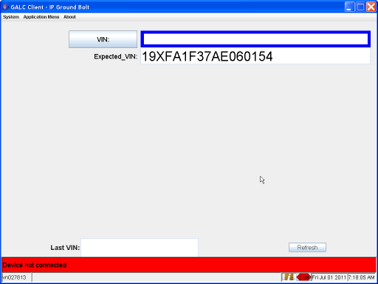

Post-Conditions
- Run the Cleanup.sql script for this station to remove the installed parts and product result records, update the last passing process point for the frame, and update the expected VIN for the process point

Test Case 13 – Skip part on last serial number

Pre-Conditions
- Process Point must be setup using configuration services
- PartName records must exist for all parts to be installed at the process point
  - PartName records can be created using the Part Category Maintenance screen
- Part records must exist for all parts to be installed at the process point
  - Part records can be created using the Part Maintenance screen
- LotControlRule records must exist for all parts to be installed at the process point for the MTOC of the VINs used in testing
  - LotControlRule records can be created using the Lot Control Rule Maintenance screen
- Execute the sql setup script for this process point. This resets the expected VIN for the process point and removes the product result, installed part, and measurement records for the VINs for this process point.

Purpose
The purpose of this station is to collect serial numbers and measurements for the parts installed at the station, and alert the user to any problems with the parts or frame.
What’s Accomplished?
The successful execution of this test case:
- Tests that the station functions without errors when all data is valid
- Tests that all serial numbers and measurements are recorded to the database successfully
- Tests that the station successfully enable and disables the gun
- Test that the station successfully changes the parameter set of the gun

Major Tables
- GAL185TBX Installed Part
- GAL143TBX Frame
- GAL215TBX Product Result
- GAL135TBX Expected Product
- HMIN_MEASUREMENT_ATTEMPTTBX Measurement Attempt

Test Steps
This section describes the steps to be taken in order to execute the test.

Step | Procedure | Expected Results | Actual Results | Pass/Fail
1 | Execute steps 1 – 6 of the normal flow (Test Case 1) | Same as Test Case 1 | As expected | Pass
2 | Scan or manually enter a unique serial number for the current serial number text box | The S/N appears on the screen. | SN displayed | Pass
3 | System checks for a duplicate S/N on a different VIN. | No errors occur. | As expected | Pass
4 | System verifies the S/N matches the part mask. | No errors occur. | As expected | Pass
5 | System returns that the S/N is good | The current serial number text box turns green and the focus and blue border move to the next serial number text box or measurement value text box | Serial box turned green and focus moved to next box | Pass
6 | System creates an installed part record in the database | Database contains an installed part record with an “Accept” status if the part does not require any torques or “OK” status if it does require at least one torque. | Record created successfully | pass
7 | Repeat steps 7-11 for all but the last serial number | No errors occur | As expected | Pass
8 | For the last serial number scan the skip barcode or click the skip button on the client | The last S/N box turns red. An installed part with a bad status is saved to the database. Focus and the blue border move to the first measurement. The torque gun is enabled with the correct pset. | As expected | Pass
9 | Resume normal flow | Results same as normal flow | As expected | Pass

Step 8 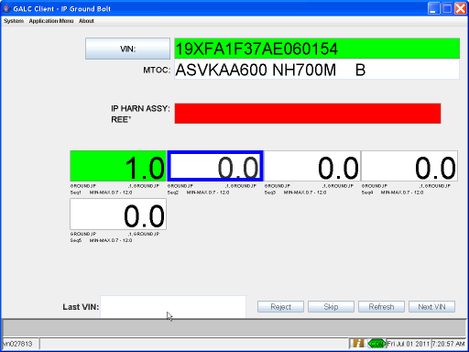

Post-Conditions
- Run the Cleanup.sql script for this station to remove the installed parts and product result records, update the last passing process point for the frame, and update the expected VIN for the process point

Test Case 14 – Reject the last serial number

Pre-Conditions
- Process Point must be setup using configuration services
- PartName records must exist for all parts to be installed at the process point
  - PartName records can be created using the Part Category Maintenance screen
- Part records must exist for all parts to be installed at the process point
  - Part records can be created using the Part Maintenance screen
- LotControlRule records must exist for all parts to be installed at the process point for the MTOC of the VINs used in testing
  - LotControlRule records can be created using the Lot Control Rule Maintenance screen
- Execute the sql setup script for this process point. This resets the expected VIN for the process point and removes the product result, installed part, and measurement records for the VINs for this process point.

Purpose
The purpose of this station is to collect serial numbers and measurements for the parts installed at the station, and alert the user to any problems with the parts or frame.
What’s Accomplished?
The successful execution of this test case:
- Tests that the station functions without errors when all data is valid
- Tests that all serial numbers and measurements are recorded to the database successfully
- Tests that the station successfully enable and disables the gun
- Test that the station successfully changes the parameter set of the gun

Major Tables
- GAL185TBX Installed Part
- GAL143TBX Frame
- GAL215TBX Product Result
- GAL135TBX Expected Product
- HMIN_MEASUREMENT_ATTEMPTTBX Measurement Attempt

Test Steps
This section describes the steps to be taken in order to execute the test.

Step | Procedure | Expected Results | Actual Results | Pass/Fail
1 | Execute steps 1 – 6 of the normal flow (Test Case 1) | Same as Test Case 1 | As expected | Pass
2 | Scan or manually enter a unique serial number for the current serial number text box | The S/N appears on the screen. | SN displayed | Pass
3 | System checks for a duplicate S/N on a different VIN. | No errors occur. | As expected | Pass
4 | System verifies the S/N matches the part mask. | No errors occur. | As expected | Pass
5 | System returns that the S/N is good | The current serial number text box turns green and the focus and blue border move to the next serial number text box or measurement value text box | SN box turned green and focus moved to next box | Pass
6 | System creates an installed part record in the database | Database contains an installed part record with an “Accept” status if the part does not require any torques or “OK” status if it does require at least one torque. | Record created | Pass
7 | Repeat steps 7-11 for all serial number boxes | No errors occur | As expected | pass
8 | On the first measurement of each part the system sends an enable and instruction code to the torque gun according to the lot control rule | The torque gun is enabled and the parameter set is correct | Gun enabled with correct pset | Pass
9 | Scan the reject barcode or click the reject button | The focus and blue border moves back to the last serial number. The status of the installed part record is changed to bad. The torque gun is disabled. | Focus moved back to last serial and gun was disabled | Pass
10 | Resume normal flow | Results same as normal flow | As expected | Pass

STEP 1 – 8
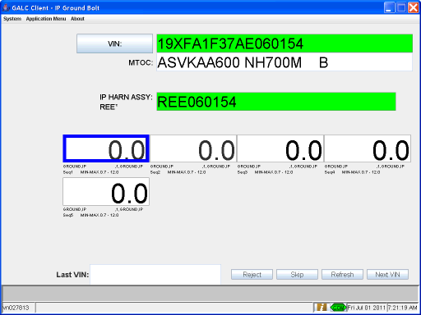

STEP 9 REJECT BUTTON
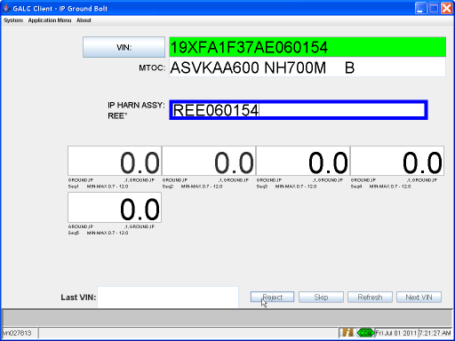

Post-Conditions
- Run the Cleanup.sql script for this station to remove the installed parts and product result records, update the last passing process point for the frame, and update the expected VIN for the process point

Test Case 15 – Skip a measurement to another measurement with the same instruction code

Pre-Conditions
- Process Point must be setup using configuration services
- PartName records must exist for all parts to be installed at the process point
  - PartName records can be created using the Part Category Maintenance screen
- Part records must exist for all parts to be installed at the process point
  - Part records can be created using the Part Maintenance screen
- LotControlRule records must exist for all parts to be installed at the process point for the MTOC of the VINs used in testing
  - LotControlRule records can be created using the Lot Control Rule Maintenance screen
- Execute the sql setup script for this process point. This resets the expected VIN for the process point and removes the product result, installed part, and measurement records for the VINs for this process point.

Purpose
The purpose of this station is to collect serial numbers and measurements for the parts installed at the station, and alert the user to any problems with the parts or frame.
What’s Accomplished?
The successful execution of this test case:
- Tests that the station functions without errors when all data is valid
- Tests that all serial numbers and measurements are recorded to the database successfully
- Tests that the station successfully enable and disables the gun
- Test that the station successfully changes the parameter set of the gun

Major Tables
- GAL185TBX Installed Part
- GAL143TBX Frame
- GAL215TBX Product Result
- GAL135TBX Expected Product
- HMIN_MEASUREMENT_ATTEMPTTBX Measurement Attempt

Test Steps
This section describes the steps to be taken in order to execute the test.

Step | Procedure | Expected Results | Actual Results | Pass/Fail
1 | Execute steps 1 – 11 of the normal flow (Test Case 1) | Same as Test Case 1 | As expected | Pass
2 | On the first measurement of each part the system sends an enable and instruction code to the torque gun according to the lot control rule | The torque gun is enabled and the parameter set is correct | Gun enabled with correct pset | Pass
3 | Scan the skip barcode or click the skip button on the client screen | The measurement box turns red. Focus and the blue border move to the next measurement box. The torque controller is not disabled / enabled and the pset is not changed | Measurement box turned red and focus moved to next measurement | Pass
4 | Perform a good torque for the current bolt | The torque controller shows a good torque. | Controller showed a good torque | Pass
5 | System checks the status and measurement values against the GALC limits | No errors occur | As expected | Pass
6 | System returns that the measurement is good | The current measurement field displays the measurement and turns green. The blue border moves to the next measurement box. | Measurement box turned green and focus moved to next box | Pass
7 | Repeat steps 13-16 for all measurement boxes | No errors occur | As expected | Pass
8 | System disables the torque gun | Torque gun is disabled | Gun disabled | Pass
9 | System records the measurements in the database | Database contains the measurement attempt records with the appropriate status for all measurements. The skipped bolt is recorded as a bad measurement. | Records created correctly | pass
10 | System creates a production results record and updates the last passing process point of the frame | Database contains a production result record for the VIN at this process point. The last passing process point column of the frame table is updated to this process point. | Record was created | Pass
11 | System updates the next expected VIN | The expect product record in the database for this process point is updated to the next VIN as determined by the in process product table | Record was updated | Pass
12 | System refreshes the screen | The screen is cleared. The Last Completed field displays the test VIN. The Next Expected field is updated to show the next VIN expected in sequence. | As expected | Pass

Step 3 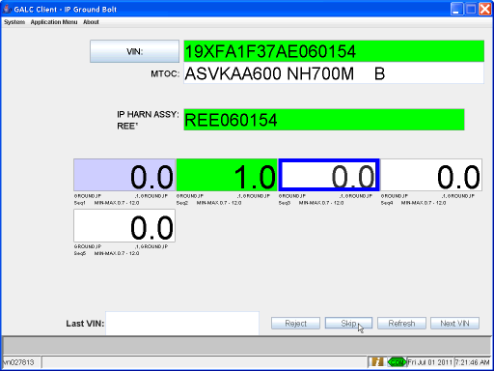

Post-Conditions
- Run the Cleanup.sql script for this station to remove the installed parts and product result records, update the last passing process point for the frame, and update the expected VIN for the process point

Test Case 16 – Reject a measurement to another measurement with the same instruction code

Pre-Conditions
- Process Point must be setup using configuration services
- PartName records must exist for all parts to be installed at the process point
  - PartName records can be created using the Part Category Maintenance screen
- Part records must exist for all parts to be installed at the process point
  - Part records can be created using the Part Maintenance screen
- LotControlRule records must exist for all parts to be installed at the process point for the MTOC of the VINs used in testing
  - LotControlRule records can be created using the Lot Control Rule Maintenance screen
- Execute the sql setup script for this process point. This resets the expected VIN for the process point and removes the product result, installed part, and measurement records for the VINs for this process point.

Purpose
The purpose of this station is to collect serial numbers and measurements for the parts installed at the station, and alert the user to any problems with the parts or frame.
What’s Accomplished?
The successful execution of this test case:
- Tests that the station functions without errors when all data is valid
- Tests that all serial numbers and measurements are recorded to the database successfully
- Tests that the station successfully enable and disables the gun
- Test that the station successfully changes the parameter set of the gun

Major Tables
- GAL185TBX Installed Part
- GAL143TBX Frame
- GAL215TBX Product Result
- GAL135TBX Expected Product
- HMIN_MEASUREMENT_ATTEMPTTBX Measurement Attempt

Test Steps
This section describes the steps to be taken in order to execute the test.

Step | Procedure | Expected Results | Actual Results | Pass/Fail
1 | Execute steps 1 – 11 of the normal flow (Test Case 1) | Same as Test Case 1 | As expected | Pass
2 | On the first measurement of each part the system sends an enable and instruction code to the torque gun according to the lot control rule | The torque gun is enabled and the parameter set is correct | Gun enabled with correct pset | Pass
3 | Perform a good torque for the current bolt | The torque controller shows a good torque. | Controller showed a good torque | Pass
4 | System checks the status and measurement values against the GALC limits | No errors occur | As expected | Pass
5 | System returns that the measurement is good | The current measurement field displays the measurement and turns green. The blue border moves to the next measurement box. | Measurement box turned green and focus moved to next box | Pass
6 | Scan the reject barcode or click the reject button on the client screen | Focus and the blue border move to the previous measurement box. The torque controller is not disabled / enabled and the pset is not changed. | Focus moved to the previous measurement and the pset was not changed | pass
7 | Perform a good torque for the current bolt | The torque controller shows a good torque. | Controller showed a good torque | Pass
8 | System checks the status and measurement values against the GALC limits | No errors occur | As expected | Pass
9 | System returns that the measurement is good | The current measurement field displays the measurement and turns green. The blue border moves to the next measurement box. | Measurement box turned green and focus moved to next measurement | Pass
10 | Repeat steps 18-20 for all measurement boxes | No errors occur | As expected | Pass
11 | System disables the torque gun | Torque gun is disabled | Controller disabled | Pass
12 | System records the measurements in the database | Database contains the measurement attempt records with the appropriate status for all measurements. | Records created successfully | Pass
13 | System creates a production results record and updates the last passing process point of the frame | Database contains a production result record for the VIN at this process point. The last passing process point column of the frame table is updated to this process point. | Record created successfully | Pass
14 | System updates the next expected VIN | The expect product record in the database for this process point is updated to the next VIN as determined by the in process product table | Record updated | Pass
15 | System refreshes the screen | The screen is cleared. The Last Completed field displays the test VIN. The Next Expected field is updated to show the next VIN expected in sequence. | As expected | Pass

Step 5 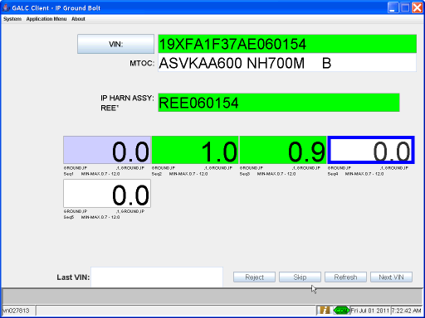
Step 6 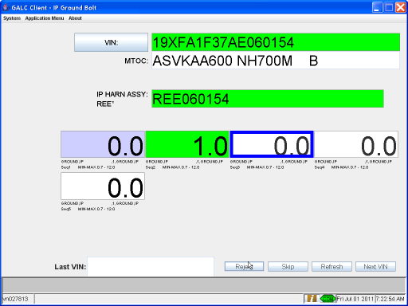

Post-Conditions
- Run the Cleanup.sql script for this station to remove the installed parts and product result records, update the last passing process point for the frame, and update the expected VIN for the process point

Test Case 17 – Skip the last measurement

Pre-Conditions
- Process Point must be setup using configuration services
- PartName records must exist for all parts to be installed at the process point
  - PartName records can be created using the Part Category Maintenance screen
- Part records must exist for all parts to be installed at the process point
  - Part records can be created using the Part Maintenance screen
- LotControlRule records must exist for all parts to be installed at the process point for the MTOC of the VINs used in testing
  - LotControlRule records can be created using the Lot Control Rule Maintenance screen
- Execute the sql setup script for this process point. This resets the expected VIN for the process point and removes the product result, installed part, and measurement records for the VINs for this process point.

Purpose
The purpose of this station is to collect serial numbers and measurements for the parts installed at the station, and alert the user to any problems with the parts or frame.
What’s Accomplished?
The successful execution of this test case:
- Tests that the station functions without errors when all data is valid
- Tests that all serial numbers and measurements are recorded to the database successfully
- Tests that the station successfully enable and disables the gun
- Test that the station successfully changes the parameter set of the gun

Major Tables
- GAL185TBX Installed Part
- GAL143TBX Frame
- GAL215TBX Product Result
- GAL135TBX Expected Product
- HMIN_MEASUREMENT_ATTEMPTTBX Measurement Attempt

Test Steps
This section describes the steps to be taken in order to execute the test.

Step | Procedure | Expected Results | Actual Results | Pass/Fail
1 | Execute steps 1 – 11 of the normal flow (Test Case 1) | Same as Test Case 1 | As expected | Pass
2 | On the first measurement of each part the system sends an enable and instruction code to the torque gun according to the lot control rule | The torque gun is enabled and the parameter set is correct | Gun enabled with correct pset | Pass
3 | Perform a good torque for the current bolt | The torque controller shows a good torque. | Controller showed a good torque | Pass
4 | System checks the status and measurement values against the GALC limits | No errors occur | As expected | Pass
5 | System returns that the measurement is good | The current measurement field displays the measurement and turns green. The blue border moves to the next measurement box. | Measurement box turned green and focus moved to next box | Pass
6 | Repeat steps 13-16 for all but the last measurement box | No errors occur | As expected | Pass
7 | Scan the skip barcode or click the skip button on the client screen | The last measurement box turns red. | Last measurement box turned red | Pass
8 | System disables the torque gun | Torque gun is disabled | Gun disabled | pass
9 | System records the measurements in the database | Database contains the measurement attempt records with the appropriate status for all measurements. The skipped measurement is recorded as bad. | Records created correctly | Pass
10 | System creates a production results record and updates the last passing process point of the frame | Database contains a production result record for the VIN at this process point. The last passing process point column of the frame table is updated to this process point. | Record created | Pass
11 | System updates the next expected VIN | The expect product record in the database for this process point is updated to the next VIN as determined by the in process product table | Record updated | Pass
12 | System refreshes the screen | The screen is cleared. The Last Completed field displays the test VIN. The Next Expected field is updated to show the next VIN expected in sequence. | As expected | Pass

Step 7 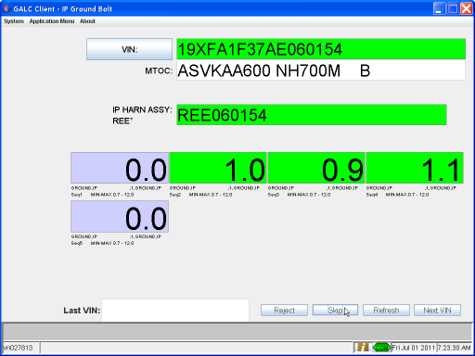

Post-Conditions
- Run the Cleanup.sql script for this station to remove the installed parts and product result records, update the last passing process point for the frame, and update the expected VIN for the process point

Test Case 18 – User is not a member of any active directory groups

Pre-Conditions
- Process Point must be setup using configuration services
- PartName records must exist for all parts to be installed at the process point
  - PartName records can be created using the Part Category Maintenance screen
- Part records must exist for all parts to be installed at the process point
  - Part records can be created using the Part Maintenance screen
- LotControlRule records must exist for all parts to be installed at the process point for the MTOC of the VINs used in testing
  - LotControlRule records can be created using the Lot Control Rule Maintenance screen

Purpose
The purpose of this station is to collect serial numbers and measurements for the parts installed at the station, and alert the user to any problems with the parts or frame.
What’s Accomplished?
The successful execution of this test case:
- Tests that the system successfully will allow a user that does not belong to any active directory groups and has never logged into a PC to login on a station with default group access. (all users allowed)

Major Tables
- GAL185TBX Installed Part
- GAL143TBX Frame
- GAL215TBX Product Result
- GAL135TBX Expected Product
- HMIN_MEASUREMENT_ATTEMPTTBX Measurement Attempt

Test Steps
This section describes the steps to be taken in order to execute the test.

Step | Procedure | Expected Results | Actual Results | Pass/Fail
1 | Verify the station has group 77 (default group) access and tart the client station | The user login dialog is displayed | User login dialog displayed | Pass
2 | Enter a user id that is not a member of any active directory groups and does not have a last logon date and click ok | User id is accepted and client starts normally | As expected | Pass

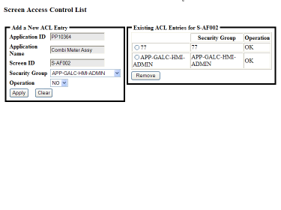
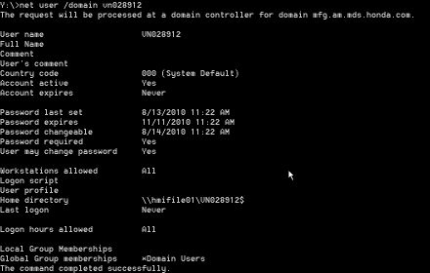

Step 1 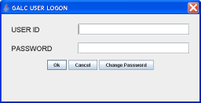

Step 2 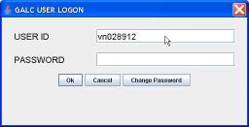
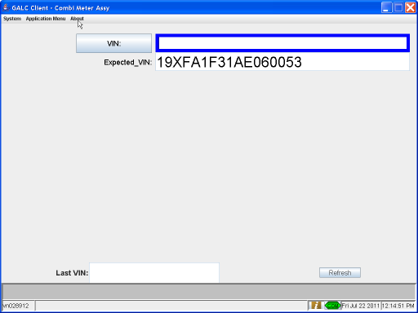

Post-Conditions
- Run the Cleanup.sql script for this station to remove the installed parts and product result records, update the last passing process point for the frame, and update the expected VIN for the process point

Test Case 19 – Sequence Reset When VIN Not The Next Expected

Pre-Conditions
- Process Point must be setup using configuration services
- PartName records must exist for all parts to be installed at the process point
  - PartName records can be created using the Part Category Maintenance screen
- Part records must exist for all parts to be installed at the process point
  - Part records can be created using the Part Maintenance screen
- LotControlRule records must exist for all parts to be installed at the process point for the MTOC of the VINs used in testing
  - LotControlRule records can be created using the Lot Control Rule Maintenance screen

Purpose
The purpose of this station is to collect serial numbers and measurements for the parts installed at the station, and alert the user to any problems with the parts or frame.
What’s Accomplished?
The successful execution of this test case:
- Tests that the system successfully alerts the user that the scanned VIN is not the next expected.
- Tests that the system can successfully proceed based on the user’s input.

Major Tables
- GAL185TBX Installed Part
- GAL143TBX Frame
- GAL215TBX Product Result
- GAL135TBX Expected Product
- HMIN_MEASUREMENT_ATTEMPTTBX Measurement Attempt

Test Steps
This section describes the steps to be taken in order to execute the test.

Step | Procedure | Expected Results | Actual Results | Pass/Fail
1 | Start the client station | The torque gun is disabled and the next expected VIN is displayed on the screen | Gun disabled | Pass
2 | Scan the Body Assembly Sheet or manually enter the next exptected VIN | VIN is displayed on screen in the VIN field | Vin displayed | Pass
3 | System checks that the VIN is 17 characters | No errors occur | No errors | Pass
4 | System verifies the VIN is the next expected | No errors occur | No errors | pass
5 | Complete the normal flow steps to finish the cycle for the scanned VIN | Cycle completes without error and the next expected VIN is updated according to the in process product table(GAL176TBX) | As expected | Pass
6 | Re-enter the same VIN entered in step 2 | VIN is displayed on screen in the VIN field | Vin displayed | Pass
7 | System checks that the VIN is 17 characters | No errors occur | No errors | Pass
8 | System verifies the VIN is the next expected | A NG sound is played and a pop-up windows appears asking: “Entered VIN does not match Expected VIN. Continue using entered VIN?” Processing is stopped until “OK” or ‘No” is selected on the pop-up. | Pop-up displayed | pass
9A | Select “Yes” on pop-up | Pop-up disappears and processing continues as normal with VIN entered | Pop-up closed, process continued | Pass
9B | Select “No” on pop-up | Pop-up disappears and screen is refreshed to initial state | Pop-up closed screen refreshed | Pass
10 | Complete the normal flow steps to finish the cycle for the scanned VIN | Cycle completes without error and the next expected VIN is updated according to the in process product table(GAL176TBX). | As expected | Pass

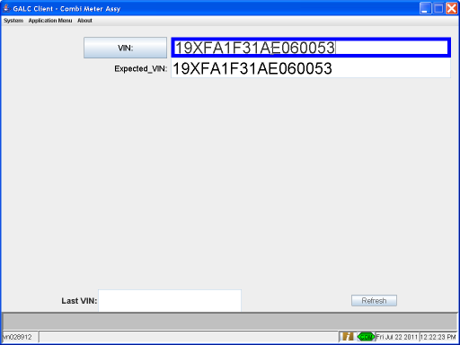

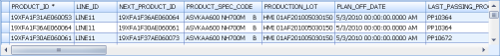

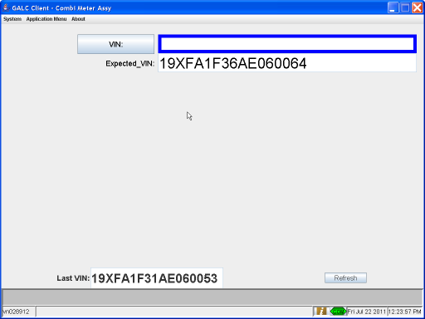

Step 4 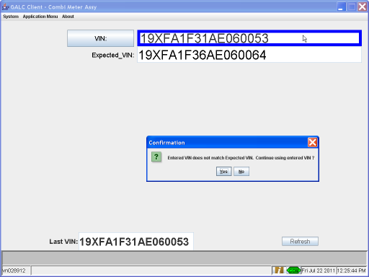

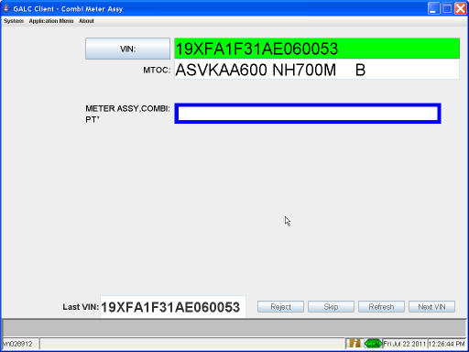

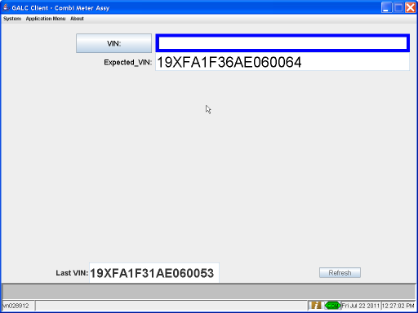

Post-Conditions
- Run the Cleanup.sql script for this station to remove the installed parts and product result records, update the last passing process point for the frame, and update the expected VIN for the process point

Test Case 20 – Next VIN

Pre-Conditions
- Process Point must be setup using configuration services
- PartName records must exist for all parts to be installed at the process point
  - PartName records can be created using the Part Category Maintenance screen
- Part records must exist for all parts to be installed at the process point
  - Part records can be created using the Part Maintenance screen
- LotControlRule records must exist for all parts to be installed at the process point for the MTOC of the VINs used in testing
  - LotControlRule records can be created using the Lot Control Rule Maintenance screen
- Execute the sql setup script for this process point. This resets the expected VIN for the process point and removes the product result, installed part, and measurement records for the VINs for this process point.

Purpose
The purpose of this station is to collect serial numbers and measurements for the parts installed at the station, and alert the user to any problems with the parts or frame.
What’s Accomplished?
The successful execution of this test case:
- Tests that the Next VIN button successfully clears the current input data on the screen.
- Tests that the Next VIN button updates the Expected VIN and the Last Completed VIN successfully.

Major Tables
- GAL185TBX Installed Part
- GAL143TBX Frame
- GAL215TBX Product Result
- GAL135TBX Expected Product
- HMIN_MEASUREMENT_ATTEMPTTBX Measurement Attempt

Test Steps
This section describes the steps to be taken in order to execute the test.

Step | Procedure | Expected Results | Actual Results | Pass/Fail
1 | Execute steps 1 – 15 of the normal flow (Test Case 1) | Same as Test Case 1 | As expected | Pass
2 | Click on the Next VIN button | A pop-up appears to confirm move to next VIN | Pop-up displayed | Pass
3 | Click on the “No” button | Pop-up disappears. Screen remains unchanged. | Pop-up closed | pass
4 | Click on the Next VIN button | The torque gun is disabled. | Gun disabled | Pass
5 | System creates a production results record and updates the last passing process point of the frame | Database contains a production result record for the VIN at this process point. The last passing process point column of the frame table is updated to this process point. | Records created | Pass
6 | System updates the next expected VIN | The expect product record in the database for this process point is updated to the next VIN as determined by the in process product table | Expected product updated | Pass
7 | System refreshes the screen. | The screen is cleared to the default state. The Next Expected VIN field is updated to the next VIN. The Last Completed field is updated to the test VIN. Processing starts over the same as the normal flow for the next VIN. | Screen refreshed | Pass
8

Step 3 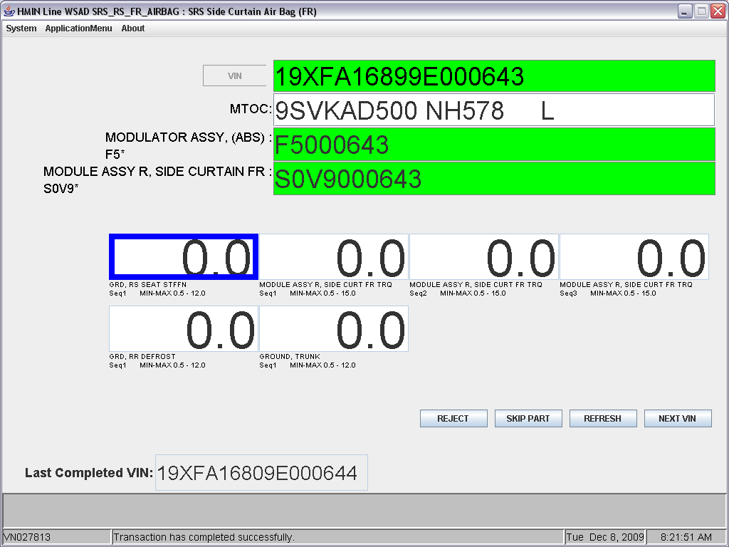
Step 5 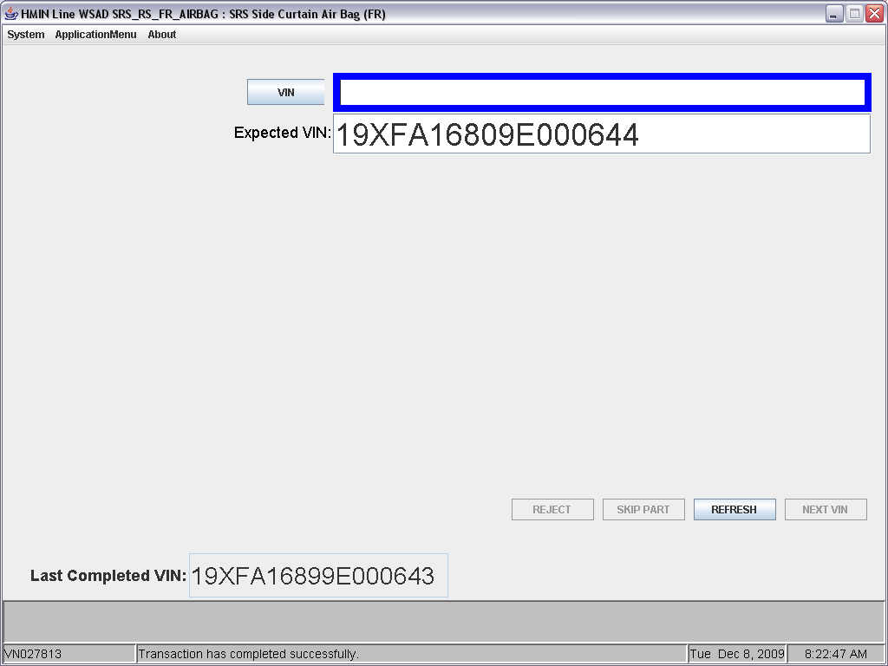

Post-Conditions
- Run the Cleanup.sql script for this station to remove the installed parts and product result records, update the last passing process point for the frame, and update the expected VIN for the process point

